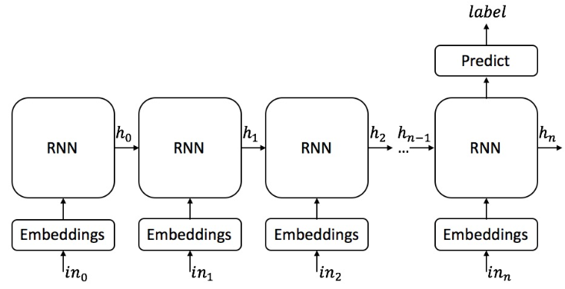

For simplicity, this diagram represents only the forward direction. Our model is bi-directional.

Each RNN cell is a drop out wrapper than contains 2 GRU cells(meaning we have h0 and h0’). In each GRU cell we have X hidden units.

